**PREPARATION OF DRAWINGS OF PARTS BY USING SOFTWARE (SOLIDWORKS)**

First of all, it should be mentioned that most of the students have not come across CAD programs, so the first step would be to familiarize the students with the user interface and the program's capabilities.

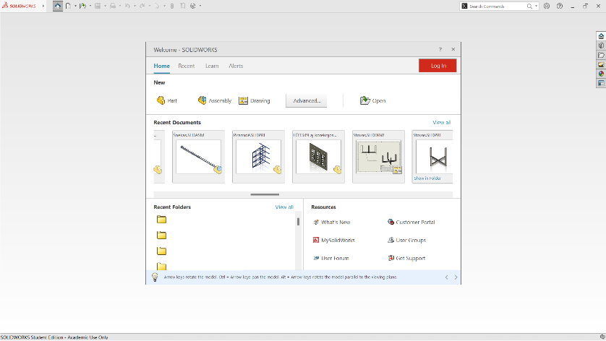

Figure 1. The primary window of the user interface

Here we can choose what we want to do with the program:

• Design a part or element

• Design assembly unit

• Make a working drawing of the part

• Open an existing drawing

• Open the helper

• Open a user forum or service area.

After choosing to design a part, we will see the following user interface where we can already perform the desired design work.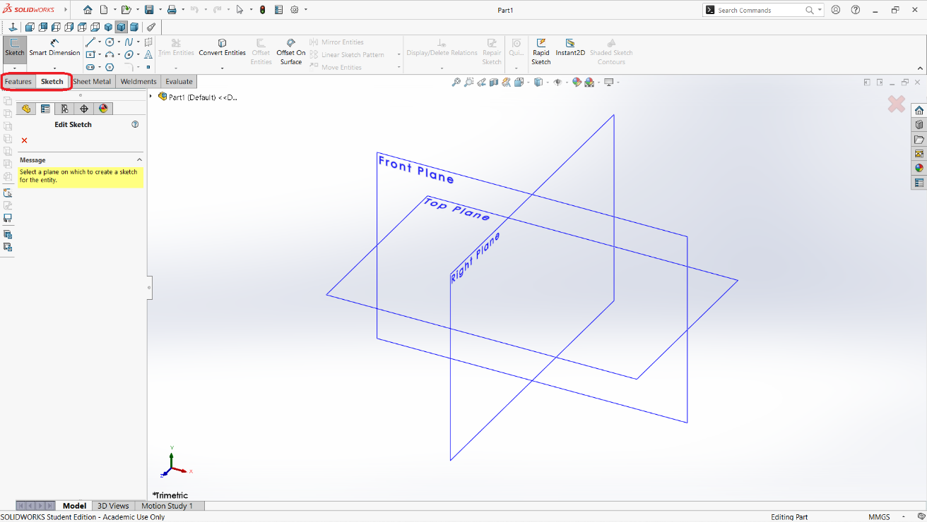

Figure 2. Working interface of Solidworks design.

As we can see in the picture, the design is possible in three planes: front, top and right.

It should be mentioned that at the very beginning of learning, only the first two design areas are enough for us: sketch and features.

* Sketch. This area is intended for drawing part sketches, geometric shapes, setting dimensions, selecting line types, line intersections, deleting, copying, moving, multiplying and otherwise editing the contours or other parameters of the part being drawn.

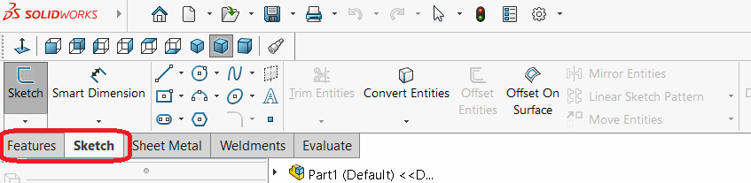

Figure 3. Sketch area

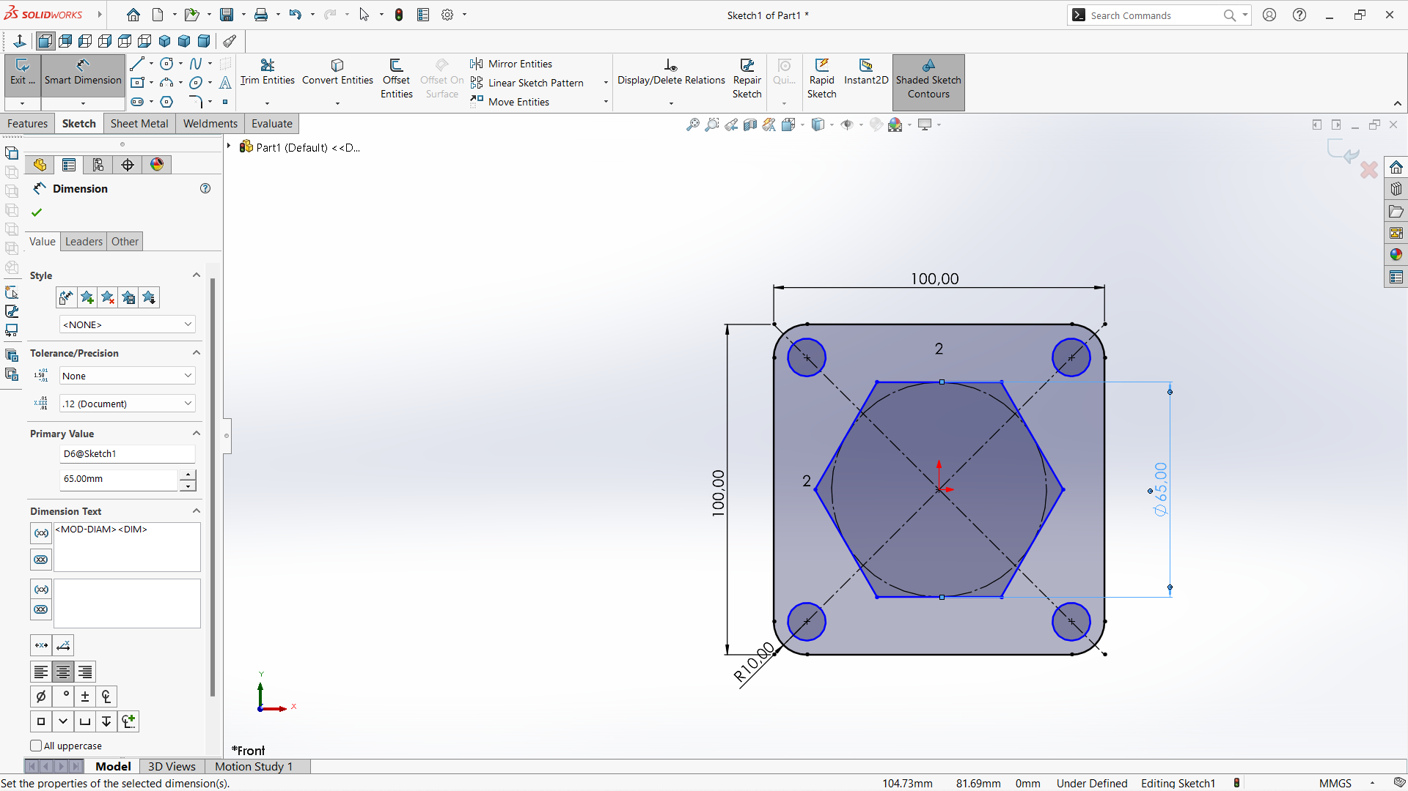

Figure 4. Sketch of a part

* Features – settings. In this area, we can already create a certain 3d shape from the sketch, which becomes similar to the shape of the desired part. Here you can not only stretch, turn around, connect, cut, round the edges of a part, but there are many other options for modifying the part.

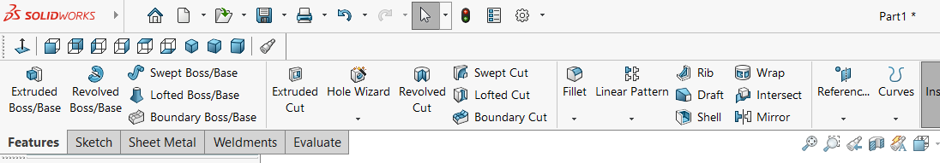

Figure 5. Features area

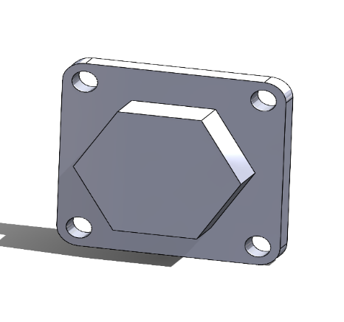

Figure 6. 3D sketch of a part made on the basis of 2D sketch

So, once we have a designed part, we can print it with a 3D printer. All you have to do is save the file in the required format. If the printer supports STL. format, in the Solidworks program we select: Files -> Save As, in the menu that appears we select the file type STL and press the Save icon. The program will automatically format the part and prepare it for printing.

The last step is to print the detail. According to the printer manufacturer's instructions, we transfer the file to the printer software. We select the relevant parameters: position relative to the table, printing material, speed, layer thickness and other parameters. We press the start operation button and wait for the result.