**Activity No 1: Reading of prepared electrical diagrams and drawings.**

During this task, students describe an electrical circuit based on the symbols of electrical diagrams presented in the standards: they indicate what devices and devices are used in the diagram, find out their principles of operation, observe their interconnections and interpret the operation of the entire diagram.

**The purpose of the task:** to help students understand device control systems, their operation, learn to read diagrams.

**Learning objectives**:

• To refresh the knowledge of the laws of electrical engineering and phenomena occurring in electrical circuits.

• To refresh the knowledge on electromechanical and electronic control devices.

• To refresh the knowledge of the basics of logical control, basic logical functions.

• To refresh the knowledge of operation of electric motors and connection requirements.

• Analyze the presented scheme.

**1 table. Electromechanical control devices. Basic information**

|  |  |  |
| --- | --- | --- |
| **Marking in the diagrams** | **Explanation** | **Additional information** |
|  | Four-pole automatic circuit breaker 3P+N for disconnecting the electrical circuit when the rated current is exceeded (in case of overloads and short circuits). | 1.<https://www.consumerunitworld.co.uk/what-is-an-mcb-and-how-does-it-work-328-c.asp>  2.<https://www.youtube.com/watch?v=Unh99Qn7CmI&t=5s> |
|  | Four-pole residual current relay (RCD). Disconnects the electrical circuit in case of current leakage. | 1.<https://www.youtube.com/watch?v=6OgaB0BIj18>  2.<https://www.electricalsafetyfirst.org.uk/guidance/safety-around-the-home/rcds-explained/> |
|  | Contactor contacts close when power is supplied to the contactor coil. | 1.<https://www.youtube.com/watch?v=7BkwQrahHv0>  2.<https://www.c3controls.com/white-paper/basics-of-contactors/> |
|  | Connecting button. Connects contacts when pressed; connects the electrical circuit. | 1.<https://www.quisure.com/blog/faq/what-are-the-push-button-switches-commonly-used-by-electricians> |
|  | Disconnecting button. Disconnects the contacts when pressed, breaks the electrical circuit. |
|  | Three-phase asynchronous alternating current electric motor for turning mechanisms. Replaces electrical energy with mechanical energy. Three-phase AC is supplied to U1, V1, W1, PE for ground connection. | 1.<https://hermitageautomation.com/ac-motor-and-how-it-works/>  2.<https://www.youtube.com/watch?v=6BcpqDEW824> |
|  | Contactor (relay) electromagnet (winding/coil). When supplying power to A1 and A2 switches the contacts. | 1.<https://www.youtube.com/watch?v=7BkwQrahHv0>  2.<https://www.c3controls.com/white-paper/basics-of-contactors/> |
|  | Thermal protection with maximum current disconnector. Protects circuits from overloads when the rated current is exceeded. | 1.<https://www.youtube.com/watch?v=v6Kkd0VgwyM>  2.<https://www.electrical4u.com/motor-protection-circuit-breaker/> |

More electrical, electronic and control symbols with descriptions can be found here:

<https://www.electricaltechnology.org/2019/09/electric-motors-symbols.html>

<https://www.electricaltechnology.org/2019/09/fuse-circuit-breaker-symbols.html>

<https://www.electricaltechnology.org/2019/09/switch-push-button-symbols.html>

<https://engineershub.co.in/electrical-symbols/>

**Table 2. Logic functions of electrical circuits. Basic information**

|  |  |  |  |  |
| --- | --- | --- | --- | --- |
| **Symbol of logical element** | **The equivalent of an electrical circuit** | **Title** | **Purpose** | **Table of meanings** |
|  |  | Logical “AND” | Create a high voltage level at the Y output when the A and B inputs are at a high voltage level. | |  |  |  | | --- | --- | --- | | **A** | **B** | **Y** | | 0 | 0 | 0 | | 0 | 1 | 0 | | 1 | 0 | 0 | | 1 | 1 | 1 | |
|  |  | Logical “OR” | Create a high voltage level at the Y output when there is a high voltage level at the A or B inputs | |  |  |  | | --- | --- | --- | | **A** | **B** | **Y** | | 0 | 0 | 0 | | 0 | 1 | 1 | | 1 | 0 | 1 | | 1 | 1 | 1 | |
|  |  | Repeater  “YES” | Create high voltage level at output Y when input A is high voltage level (repeat) | |  |  | | --- | --- | | **A** | **Y** | | 0 | 0 | | 1 | 1 | |
|  |  | Inverter  “NO” | At the output Y, change the logic level of the input A by the opposite value – invert. | |  |  | | --- | --- | | **A** | **Y** | | 0 | 1 | | 1 | 0 | |

**Briefly about the operation of an asynchronous motor**

Asynchronous squirrel-cage motor belongs to the type of alternating current motors. The structure of the motor is simple: it has a body, a stationary part (stator), a moving part - the rotor and bearing covers (bearings of the rotor). The stator consists of a magnet wire of electrotechnical steel plates and windings wound in the grooves in it. When a three-phase alternating current is connected, the stator windings create an alternating magnetic field moving in space (rotating). The stator windings are connected in star (for higher mains voltage) or delta (for lower mains voltage). The technical passport of the motor indicates how to connect the windings at a certain mains voltage.

The rotor has a shaft on which another magnet wire is installed, in which the windings are cast from metal and are short-circuited with each other. Under the influence of a changing magnetic field, the rotor begins to rotate due to the currents induced in it.

The structure of the induction motor is provided in the link:<https://electricalacademia.com/induction-motor/three-phase-induction-motor-construction/>

Ways to connect the windings are presented in the online video: <https://www.youtube.com/watch?v=jN7o7xvO6Pc>

More detailed information in English about each engine type and performance is available at the link: [**https://slideplayer.com/slide/9477186/**](https://slideplayer.com/slide/9477186/)

**Below is the motor control circuit. Analyze the circuit in the following steps:**

1.Based on the sources below, identify the components of the diagram.

• <https://engineershub.co.in/electrical-symbols/>

• <https://suvirinimopasaulis.lt/elektriniu-schemu-simboliai-ir-zymejimai/>

2. Based on the references given at the end of the document, find out the principles of operation and control of devices.

3. After clarifying the components and their operation, describe the operation of the diagram, distinguishing between the motor power supply circuit (motor working current flows, power circuit) and the control circuit (control hardware current flows).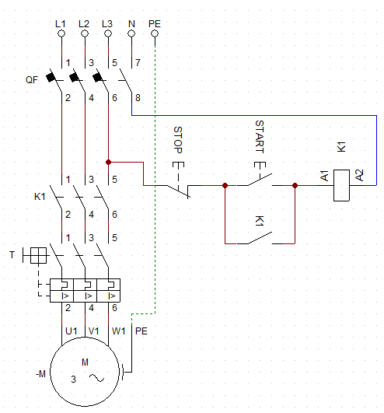 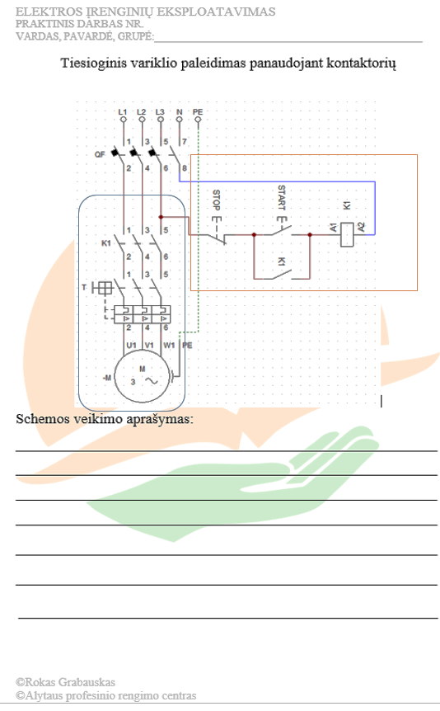

Figure 1. Motor control schematic diagram on the left and task sheet on the right

|  |  |
| --- | --- |
| Marking of component | Title (1) and definition (2) of component |
|  |  |
|  |  |
|  |  |
|  |  |
|  |  |
|  |  |
|  |  |
|  |  |
|  |  |
| Description of the operation of the circuit (3) | |
| The circuit consists of a power circuit (square of smoothed corners) and a control circuit (square of right angles). QF - double-circuit protection circuit breaker - protects the control and power circuits from overcurrents and also acts as a main switch. The power circuit consists of a controlled power device - a three-phase motor (M), which is turned on / off by a contactor of the control circuit (K1), connecting the power contacts and a motor overload protection - a thermal relay (T).  The control circuit consists of the "STOP" button of the breaking contact, the "START" button of the connecting contact and the connecting contact of the contactor K1 connected in parallel with it, followed by the coil of the contactor K1.  When the automatic switch QF is turned on, the supply voltage appears in the upper part of the power contacts K1; from the branch, through the STOP button, reaches the START button. When the START button is pressed, the voltage supplies the contactor K1 and the power contacts in the power circuit and the additional contact K1 close. Additional contact K1 creates a new path for the current, bypassing the START button and when the button is released, the contactor powers itself.  When the contactor operates and the power contacts close, voltage is supplied to the motor through the connected thermal protection T and the motor starts to rotate.  To stop the operation of the motor, it is necessary to turn off the contactor in the control circuit (by pressing the STOP button, the voltage to the control circuit and the contactor is disconnected. The contactor turns off and disconnects the motor from the supply voltage via power contacts K1).  Control and power circuits can be switched off with a QF circuit breaker. | |

**Additional sources**:

Contactors:

1. <https://www.youtube.com/watch?v=7BkwQrahHv0>
2. <https://www.c3controls.com/white-paper/basics-of-contactors/>

Autyomatic switches:

1. <https://www.consumerunitworld.co.uk/what-is-an-mcb-and-how-does-it-work-328-c.asp>
2. <https://www.youtube.com/watch?v=Unh99Qn7CmI&t=5s>

Current leakage relays:

1. <https://www.youtube.com/watch?v=6OgaB0BIj18>
2. <https://www.electricalsafetyfirst.org.uk/guidance/safety-around-the-home/rcds-explained/>

Thermal protection of motor:

1. <https://www.youtube.com/watch?v=v6Kkd0VgwyM>
2. <https://www.electrical4u.com/motor-protection-circuit-breaker/>

Motors and their connection:

1. <https://hermitageautomation.com/ac-motor-and-how-it-works/>
2. <https://www.youtube.com/watch?v=6BcpqDEW824>

**Assessment**:

1. The student's computer skills in using Internet resources (opening links, using a browser) and working with a text editor are assessed.
2. The student's abilities to independently understand information by analyzing and describing the operation of devices and schemes are assessed.
3. Finally, analytical and logical thinking abilities to analyze and understand, consistently and clearly present the operation of the scheme are evaluated.