**READING AND UDERSTANDING OF THE PRINTED DRAWINGS**

In many cases, students come with no idea what a drawing is or what it shows. Therefore, learning this subject starts with a basic knowledge of theory:

Design methods:

(a) European - first angle method;

(b) American - third-angle method.

Graphic symbol

The graphic symbol for the first angle projection method is shown in Figure 1. The proportions and dimensions of this graphic symbol are defined by ISO 5456-2.

The graphic symbol for the third angle projection method is shown in Figure 2. The proportions and dimensions of this graphic symbol are defined by ISO 5456-2.

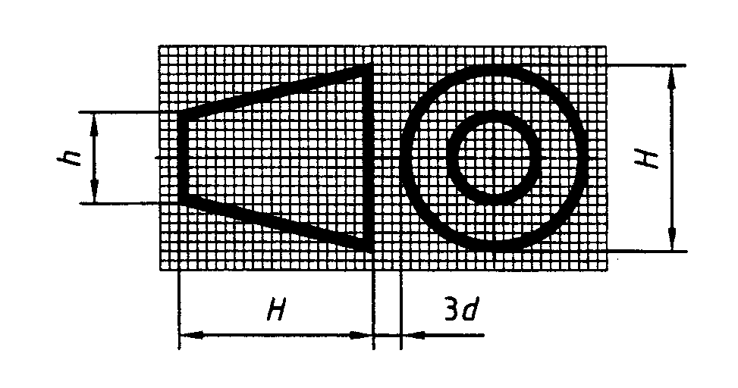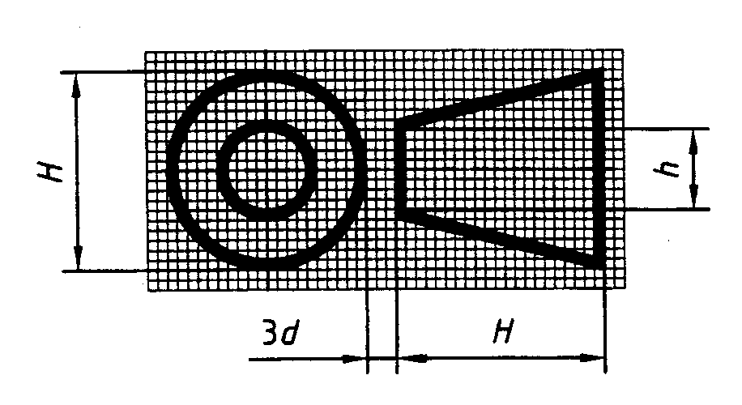

Fig. 2. American method.

Fig 1. European method;

**Images and their position in the drawings**

First-angle projection method - European first-angle method;

In relation to the front view (a), the other views are placed in the following order (see Figure A.1):

- the top view (b) is placed at the bottom;

- the bottom view (e) is placed on top;

- the left-hand view (c) is placed on the right;

- the right-hand view (d) is placed on the left;

The rear view (f) may be placed as convenient, either on the left or on the right

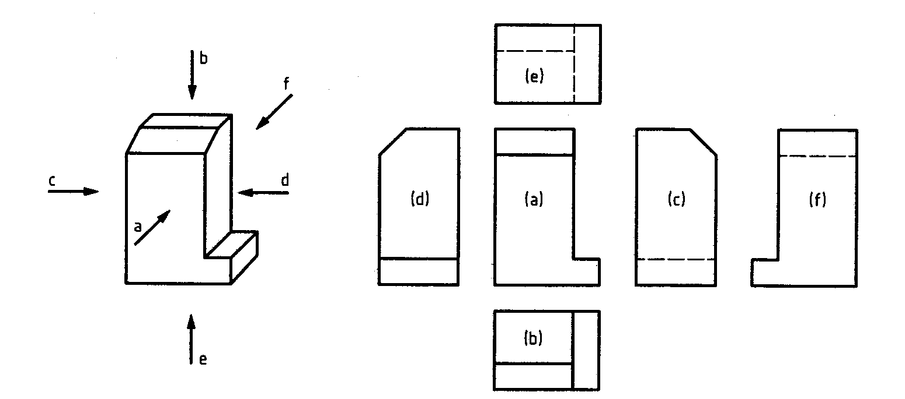

Fig 3. Images and their projections in the drawings

- Scales:

a. Scaling down

b. Increasing

- Lines:

a.Types

b. Areas

c. Element lengths

d.Spacing

e.Line precedence

f.Intersections of lines

Types of Lines

ISO standards foresee 15 basic types of lines:

|  |  |
| --- | --- |
|  | 01 solid line  02 dashed line  03 dashed line with long gaps  04 a line of long dashes with a dot between  05 a line of long dashes with two dots between  06 a line of long dashed with three dots between  07 dotted line  08 line of long and short dashes  09 a line of long dashes with two short dashes  10 dash dotted line  11 a line of two dashes with a dot  12 dashed line with two dots  13 a line of two dashes with two dots  14 dashed line with three dots  15 a line of two dashes with three dots |

Few examples of application of different types of lines in drawing



Fig. 2. Examples of lines

1. Visible lines – solid thick lines.
2. Invisible lines – thin dashed lines.
3. Lines of symmetry and axes – thin lines of long dashes and dot.
4. Lines of dimensions, projection lines – solid thin lines.

- Dimensions, their types and designations.

- Geometric shapes

- Other key design principles...

References:

<https://liggd.lt/diad-tools/lt/mokymosi-medziaga>